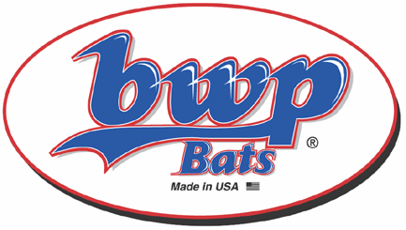
BWP Bats
80 Womeldorf Lane
Brookville, PA 15825

Phone: 814-849-0089
Cell: 814-591-7742

E-mail: shane@bwpbats.com
www.bwpbats.com
Contact: Shane Ford

Manchester Twilight League

WOOD BAT Program
2012
Prices: League (60) Team (12) Player
Pro Select Maple $47.00 $54.00 $62.00
Pro White Ash $42.00 $46.00 $52.00
Northern Red Oak $46.00 $51.00 $57.00

Wood Type:

Model:

Length:

Cupped ?:

Quantity:

Free* 1 Line Engraving (20 characters max.):

2nd Line (Additional $2.50)-

Shipping charge: $10 (Add $2.00 for each additional bat)

*Note: To reduce shipping costs & cost per bat Bulk team orders are more cost effective*

(Below is for custom color orders only)

*PLEASE NOTE CUSTOM COLOR ORDERS WILL BE AN ADDITIONAL $5.00 CHARGE*

Handle Color-

Barrel Color-

Logo/Engraving Color-

*Orders will not be shipped until BWP Bats LLC receives payment via credit card, check, or money order*

*Most major cards accepted*

Billing Name/Address/Phone Number:

Shipping Name/Address/Phone Number:

Name of Card Holder:

Credit Card #:

Exp. Date-

Security Code-

*Please Fill Out Form In Full & attach in an email to shane@bwpbats.com *

